Associate PI
Handbook

Contents

Contents 2
Background 3
What is involved? 4
Getting started 5
Who is eligible to be an Associate PI? 5
Registration 5
Completing the Checklist 6
Associate PI Checklist 7
EXTEND specific API activities 8
Supervision 9
Local Supervision 9
EXTEND Trial Team Support 9
Benefits 10
Introduction to EXTEND Trial 11
Trial Overview 12
Eligibility assessment 13
Inclusion criteria 13
Exclusion criteria 14
Standard care vs Intervention 15
Standard care arm 15
Intervention arm 15
Choice of antibiotic 17
The EXTEND Team 18

Background

Principle investigators (PIs) are responsible for the conduct of the research at their site. Associate PIs work alongside PIs and research teams to help deliver a clinical trial. The EXTEND trial is registered with the NIHR Associate Principal Investigator (API) scheme which has been developed to enable junior doctors, nurses or allied health professionals who are interested in research to undertake research delivery training and gain experience in the delivery of a NIHR portfolio study.

What is involved?
- Registration as an Associate PI (API) trainee on the NIHR Associate PI Learning Pathway, which can be found on NIHR Learn.
- The API will spend minimum of 6 months as API.
- The API must complete a checklist of study activities online via NIHR Learn. This checklist needs to be signed off by the Local PI and the EXTEND Study Coordinator at the end of the API’s time on the scheme.
- The Local PI will act as a mentor to the EXTEND API trainee to help them understand what it means to be a Local PI on an NIHR portfolio study.
- Additional support will be available from the EXTEND study coordinator and the EXTEND API ambassadors.
- The NIHR API team will issue a certificate confirming achievement of API Status on completion of the scheme.
The purpose of this handbook is to collate all the information and resources required to successfully complete the API scheme. For a complete description of the EXTEND Trial and all study related procedures please refer to the Study Protocol.
If you have any queries on any issue relating to the EXTEND API scheme please contact the EXTEND study coordinator or Associate PI Ambassadors.

Getting started

Who is eligible to be an Associate PI?
Any trainee doctor (FY1-St8 or equivalent), nurse or allied health professional who does not have research as a core part of their role and who is able to commit to six months of working on the EXTEND trial.

Registration
If the site where you are based is already participating in the EXTEND trial all you need is approval from the site PI and the study coordinator. You will then be able to register to be an API, complete the registration form on the NIHR Associate PI Scheme webpage.
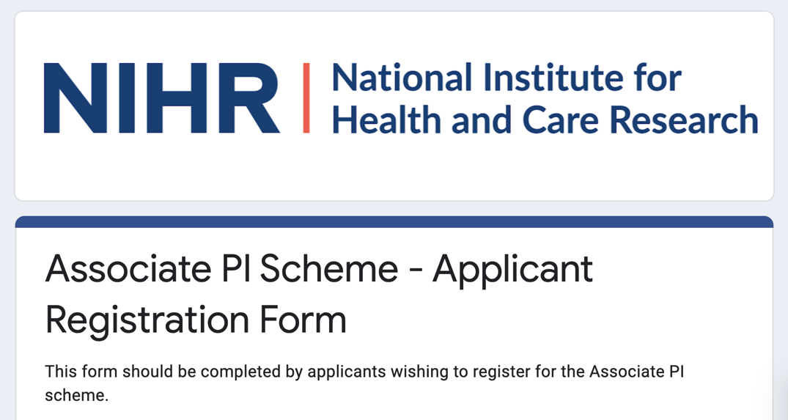
Please note: in order to be able to register, your site must have agreement from the site PI

Completing the Checklist

Once you have registered on the API scheme you will be able to download the API Checklist from the Associate PI Scheme Learning Pathway on NIHR Learn.
You are responsible for the completion of your checklist during your time on the API Scheme. The checklist has been split into monthly activities so that you can evidence your work as you go along. This evidence can then be copied directly into your checklist.
If you are not getting the chance to undertake any of the activities on your checklist, then speak to your Local PI and the EXTEND team for support on how you can complete them.
At the end of your time on the API scheme, you must ensure your completed checklist is signed by your Local PI and EXTEND study co-ordinator before it is submitted via NIHR Learn.

For more information on how to complete the API scheme please refer to the NIHR PI Toolkit.

Associate PI Checklist
APIs must demonstrate involvement in each of the core activities below as per the NIHR Associate PI Status Checklist.
Team Activities
Signed off on local EXTEND delegation Log as a research team member
Six months involvement in EXTEND
Present the EXTEND trial to local surgical, microbiology or anaesthetic teams
Attend monthly local research team meetings
These may include meetings with the PI or local research delivery team.
Attend at least one trial management group meeting
Ensure the delegation log is kept up to date
Provide staff training
This will include ensuring all new staff are GCP trained and aware of the EXTEND protocol and trained in study procedures.
Study Management / Compliance activities
Review screening to ensure appropriate patients are screened for inclusion
Ensure evidence of regular involvement is recorded.
Patient related activities
Involvement in the recruitment of a minimum of 5 patients
Involvement in data collection for participants

Please note this checklist is for guidance only.
All activities and evidence must be uploaded onto the NIHR Associate Principal Investigator (PI) Status Checklist

EXTEND specific API activities
Extend APIs are required to carry out the following additional activities:
Training
Complete Good Clinical Practice (GCP) training
Complete training for the EXTEND trial (as per the site initiation visit)
Attend GRANULES training course
For more information click here
Attend Informed Consent Training: Access real-time training webinars via NIHR Learn.
For more information click here
Attend Mental Capacity Act Training: HRA free eLearning module on research involving participants lacking mental capacity.
For more information click here: https://www.hra.nhs.uk/planning-and-improving-research/learning/learning-management-system/

Supervision

Local Supervision

Your local Principle Investigator (PI) will take overall responsibility for the conduct EXTEND trial at your research site.
Your local PI will also act as your mentor and will support you to complete the NIHR Associate PI Scheme Checklist.
Your responsibilities as API will include:
- Patient screening
- Patient recruitment, including obtaining informed consent
- Engage with local teams to publicise the trial
- Maintain trial documentations (e.g. delegation log)
- Data entry including responding to data queries
- Local staff training
Regular meetings with your local PI are important so that your PI can review your progress and identify areas where you may need more guidance and support. We would recommend you meet with your local PI fortnightly.
At the end of you 6 months as API, Your Local PI and the EXTEND Study Coordinator will need to sign off your completed checklist.

EXTEND Trial Team Support
The EXTEND trial is co-ordinated by the York Clinical Trials Unit and we have a dedicated team available to support APIs during their tenure on EXTEND.
API support team:
EXTEND Study  co-ordinator | Dr Catherine Knowlson, catherine.knowlson@york.ac.uk
API ambassadors | Dr Shadia Ahmed (Infection), shadiaahmed@nhs.net  Ms Olivia O’Connor (surgery), olivia.spence@doctors.org.uk

The study coordinator and API ambassadors will be available to support you to complete your API Scheme Checklist.
We have also set up an EXTEND API WhatsApp group so APIs can have any questions answered and raise any issues.

Benefits

By participating in the API scheme, trainees will:
- Gain practical research experience into the challenges and logistics of delivering a NIHR multicentre portfolio study​
- Have the opportunity to undergo structured training in research delivery
- Be acknowledged in any study publications as long as they meet the authorship criteria below.

EXTEND Authorship criteria for APIs

We intend APIs will be acknowledged in an EXTEND trial clinical results publication in a PubMed citeable way, which we anticipate will be in the trial appendix listed as a trial investigator when they are compliant with International Committee of Medical Journal Editors (ICJME) authorship criteria including:

- A review and approval of the trial protocol
- The acquisition of data for the work-evidenced by the involvement in recruitment and follow up of 5 patients over a 6 month period, or an equivalent rate for those involved for 4 or more months
- Critical review of the manuscript and approval of the version to be published evidenced by e-mail confirmation of manuscript review
- Agreement to be accountable for all aspects of the work in ensuring that questions related to the accuracy or integrity of any part of the work are appropriately investigated and resolved.

Introduction to EXTEND Trial

- Complicated intra-abdominal infections (cIAIs) extend beyond a hollow viscus (an organ with a lumen such as the bowel) in the abdomen into the peritoneal cavity and are associated with either abscess formation or peritonitis.
- cIAIs are the second most common cause of sepsis in patients on intensive care units (ICUs) and cause significant morbidity and mortality
- Management strategy for cIAIs centres on source control and antibiotics
- A national audit of cIAIs management in the UK showed there is variation in antibiotic treatment strategies, and there remains no UK guidance on the management of cIAIs
- The EXTEND trial aims to investigate the effectiveness of a fixed-extended-duration antibiotic strategy of 28-days.

Trial Overview
The EXTEND trial is a multicentre, open label, two-arm, parallel group, pragmatic, randomised controlled trial with an internal pilot.

A total of 1166 consenting patients with cIAI will be recruited over 3 years and randomised on a 1:1 basis to receive either standard care (clinically decided antibiotic duration) or a fixed-extended-duration of 28 days antibiotics. Patients will be recruited from ICUs and hospital in-patient wards across 30 sites.

The primary objective is to determine if a fixed-extended-duration of 28-days antibiotic treatment is superior to standard care based on clinical outcomes and quality of life assessed over six months of follow up.
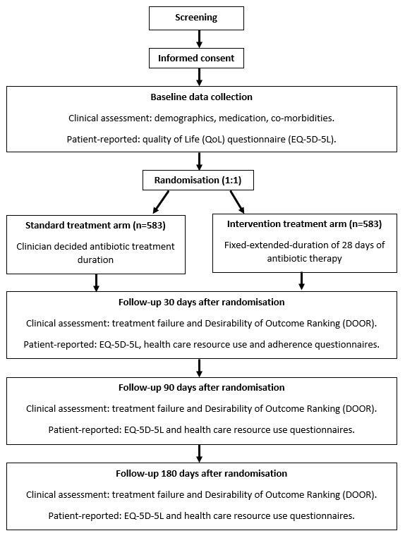

Eligibility assessment

Inclusion criteria

- Adults (≥ 16 years) with cIAI (see cIAI definition below)
- Being treated with antibiotics until the point of randomisation, but has not had more than 10 days of treatment at the time of screening
- Ability to provide informed consent by the patient or their consultee.
- More than 72 hours of further active in-patient management for the patients cIAI is planned/required
- In the event that the patient is re-admitted to hospital during the trial period, they will likely to be admitted to a hospital participating in the EXTEND trial

Patients will be included in the trial whether or not they undergo surgical or radiological source control procedures.

cIAI definition
- A clinical presentation consistent with cIAI (e.g abdominal pain, fever), plus
- Fever (temperature of ≥ 37.8°C) and/or a neutrophilia (> 7.5×109/L) and/or neutropaenia (<1.8x109/L) and/or intestinal pathogens* cultured from sterile sites (closed peritoneum or blood), plus
- Evidence of pathologic findings on radiologic examination, or
- Evidence of pathologic findings at operation

* Intestinal pathogens include Anaerobes (e.g., Bacteroides), Enterobacterales/’coliforms’ (e.g., Citrobacter, E.coli, Enterobacter, Klebsiella, Serratia), Enterococcus spp., Pseudomonas spp. and Streptococcus species

Exclusion criteria

- Perforated gastric ulcer or duodenal ulcer treated within 24 hours of the onset of symptoms.
- Traumatic injury to the bowel (including iatrogenic or intra-operative) treated within 12 hours of injury.
- Uncomplicated diverticulitis defined as an episode with a short history and with clinical signs of diverticulitis, with an increased body temperature and inflammatory parameters, verified by computed tomography (CT), and without any sign of complications such as abscess, free air or fistula.
- Non-perforated, non‐gangrenous appendicitis (Grade 4 and below of the 2017 American Association for the Surgery on Trauma Grading System) or cholecystitis.
- Ischemic or necrotic intestine without perforation
- Uterine perforation following uterine surgery treated <six hours following injury.
- cIAIs with a low risk of complications who may receive more than 72 hours antibiotics are not intended to be included, such as those listed above. Clinician assessment on the eligibility of patients receiving more than 72 hours of in-patient surgical care and antibiotics for their cIAI may be required in patients who have clinically improved at this point and do not require active surgical care but remain in hospital and on antibiotics.
- Current enrolment in another trial dictating antibiotic treatment duration.
- Previous Clostridium difficile infection
- Infected necrotic pancreatitis
- Concomitant infection requiring ≥4 weeks antibiotic therapy including Intra-hepatic abscess/es planned to be treated with fixed-extended-duration antibiotics of 4 to 6 weeks antibiotics, osteomyelitis, and endocarditis.
- Peritoneal dialysis
- Previously recruited for the EXTEND trial
- Treatment with Interleukin-6 Inhibitors
- High likelihood of death within 72 hours of randomisation in the opinion of the local Investigator
- Limitations in treatment decided before inclusion
- Patient with persistent cIAI of more than 6 months duration
- A maximum of 20% of participants entering the trial can have a source of cIAI as the appendix. If 230 patients with appendicitis as the source are recruited, this will become an exclusion criteria for subsequent patients.

Standard care vs Intervention
Participants will be randomised 1:1 between 28-days antibiotics (intervention arm) and standard care antibiotic duration.

Randomisation will occur within the first 10 days of antibiotic treatment for cIAI.

Standard care arm
When the patient has clinically improved and the inflammatory markers have improved- this should guide the stopping of antibiotics
Reflective of most peoples clinical practice
Guided by clinician assessment i.e. has the patient clinically improved?
Guided by inflammatory markers i.e. has the WCC/CRP/PCT improved?

Notes:
A. Improved does not mean “normal”.
B. Standard care may result in 1- Short courses of antibiotics e.g. 4 days, as per the SIS guidelines, or 2- Longer courses of antibiotics e.g. 4 weeks antibiotics, in a patient whose inflammatory markers do not normalise and who does not clinically improve over this period of time.
C. Overall we expect standard care to be around two weeks of antibiotics on average.

Intervention arm
A fixed-extended-antibiotic duration of 28-days effective therapy for patients with cIAI.
The start date (day 0) of antibiotics is defined as the first date of active antibiotic treatment for cIAI. This may precede diagnosis and will precede randomisation.
Effective antibiotic therapy will not include:
- Antibiotics prescribed for prophylaxis
- Treatment with antibiotics that would be poor for cIAI e.g. nitrofurantoin for cystitis
- Antibiotics that will be limited by proven antimicrobial resistance* according to standard laboratory criteria.
The antibiotic start date can be re-set to day 0 if there is evidence treatment is not active prior to randomisation
*Treatment will be considered active unless antimicrobial resistance is identified and believed to be clinically relevant I.e. antibiotic treatment is changed prior to randomisation

Choice of antibiotic

The EXTEND trial relates to the duration of antibiotic only.
The choice of antibiotic and route of administration are therefore selected by the treating clinician and may change throughout treatment.
Antibiotics may be Intravenous (IV) or Oral. Oral step-down should happen as per standard practice.
Where needed antibiotics can be administered by Out-Patient Antibiotic Therapy (OPAT) services.
Microbiology advice can be sought over antibiotic choice, especially when microbiologic reports are available, as per standard practice.

The EXTEND Team

Chief Investigators | Andrew Kirby  0113 3923929  a.kirby@leeds.ac.uk | Dermot Burke  0113 392 3465  d.burke@leeds.ac.uk
Trial manager | Sarah Cochrane  01904 321736  sarah.cockayne@york.ac.uk
Study Co-ordinator | Dr Debbie Sykes  01904 321083  debbie.sykes@york.ac.uk
Study Co-ordinator | Mo Hammouda  01904 323905  mo.hammouda@york.ac.uk
Trial Support Officer | Claire Whitmore  01904 328943  claire.whitmore@york.ac.uk
API ambassadors | Dr Shadia Ahmed (Infection)  07747 246035  shadiaahmed@nhs.net
Ms Olivia O’Connor (surgery)
07738087049
olivia.spence@doctors.org.uk
Sponsor | University of Leeds  0113 3434897  Clare Skinner: governance-ethics@leeds.ac.uk
Funder | National Institute of Health Research (NIHR)_ Health Technology Assessment funding scheme
Clinical Trials Unit | York Clinical Trials Unit
Key Protocol Contributors | Dr Shadia Ahmed, Mr Dermot Burke, Dr Rebecca Harmston, Professor Catherine Hewitt, Dr Andrew Kirby, Dr Catherine Knowlson, Professor Thomas Pinkney, Ms Olivia O’Connor, Dr Tamas Szakmany, Dr Puvan Tharmanathan, Dr Armando Vargas-Palacios, Mr Charlie Welch
Statistician | Mr Charlie Welch
Health economics | Armando Vargas-Palacios
Committees | Trial Steering Committee (TSC)  Committee chair: Professor Graeme MacLennan
Data Monitoring and Ethics Committee (DMEC)
Committee chair: Andrew Cohen
Trial Management Committee (TMG)
Committee chairs: Dr Andrew Kirby and Mr Dermot Burke
End point committee
Committee contact: Dr Andrew Kirby

